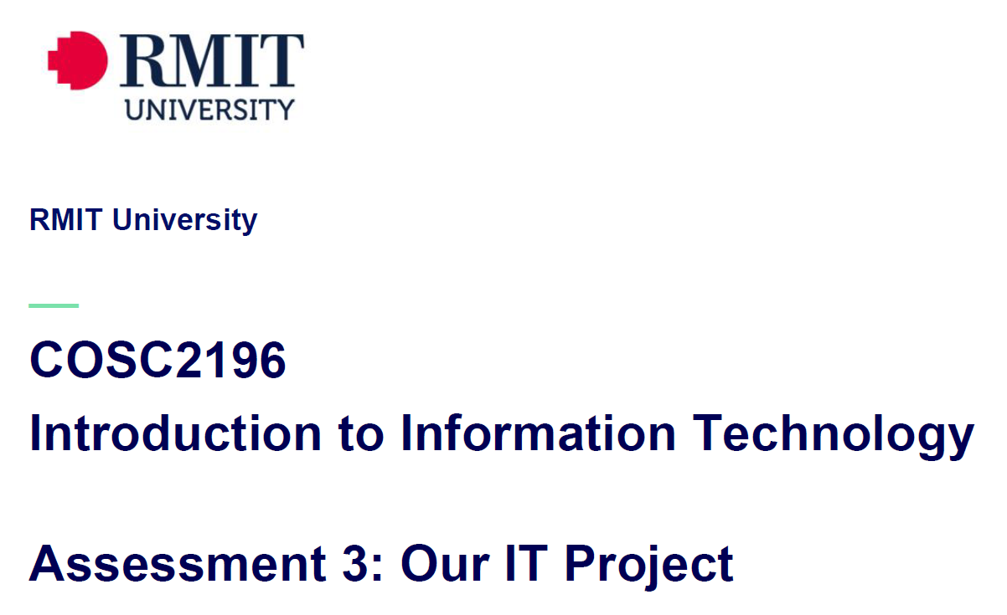
Team_Name_404 MEETING
Venue: Online via MS Teams
Date: 5/5/21

Agenda

Meeting Opened: (time)
Attendance: Paul Eccarius, Rebecca Watson, Martin Lee, Nour Zeroual
Apologies: none.
Meeting Chair:
Minutes Secretary:
- Minutes from previous Meeting -
- Actions arising as per Action Register
Meeting Date | Action | Who to action | Completed Y/N | Update at meeting | Further action
29/4/21 | Team Profile – each make 2/3s of a page as per spec.  Group processes and career plans/contrast to be done as an update on reflection/career work from A2. | Paul  Bec  Nour  Martin |  | 5/5/21
29/4/21 | Tools (GitHub) – find out best process for ‘forking’/ making version 2.0 of A2. May need to check forums or ask Umera/Anthony. | Team |  | 5/5/21 | Anthony answered on A3 discussion board: Can be cloned, can be forked, can create a new repo. Just one, then add contributors.
29/4/21 | Timeframe – research generic steps/timelines for building apps | Bec | Yes | 5/5/21 | See document uploaded in A3 channel
29/4/21 | A5 draft script + storyboard – due end of week 10. Paul to outline/mock up. | Paul |  | 5/5/21
29/4/21 | A2 Contribution – send what we have tomorrow (due date). Follow steps given via email from Umera if everyone hasn’t signed. | Bec | Yes | 5/5/21 | complete

- Has everyone had a chance to read through the Assignment/s?

ASSIGNMENT 3: Our IT Project (overall weighting 40%)

- Team Profile – 5%

- Tools – 5%
- Github?
- Website – will we build a new one from scratch or work with what we have and make changes to the framework?

- Project Plan/Description – 50%

- Overview:
- Yogi needs a logo and some sort of ‘mission statement’; colours, fonts, graphics.
Topic
Motivation
Landscape

- Detailed Description:
Aims | what are the essential parts for Yogi to basically function as per our actual and imagined timeframe
Plans & Progress
Roles
Scope and Limitations
Tools & Technologies
Testing
Timeframe
Risks
Group Processes & Communications

- Skills and Jobs – 15%

- Feedback – 7.5%

- Group Reflection – 7.5%
- Presentation – 10%

Assignment 5: Presentation (overall weighting 20%)

- Draft script + storyboard is due Sunday of Week 10
- Paul is going to have a look at putting the storyboard and a script over the long weekend.
- Specifics as per rubric:
Identification/Description
Need/Want/Users/Market
Innovation
Mechanics/Design
Length
Quality

- Additional points for discussion?

Next meeting date:
Meeting closed: (time)

Actions Register

Meeting Date | Action | Who to action | Completed Y/N | Update at meeting | Further action
29/4/21 | Team Profile – each make 2/3s of a page as per spec.  Group processes and career plans/contrast to be done as an update on reflection/career work from A2. | Paul  Bec  Nour  Martin |  | 5/5/21
29/4/21 | Tools (GitHub) – find out best process for ‘forking’/ making version 2.0 of A2. May need to check forums or ask Umera/Anthony. | Team |  | 5/5/21
29/4/21 | Timeframe – research generic steps/timelines for building apps | Bec |  | 5/5/21
29/4/21 | A5 draft script + storyboard – due end of week 10. Paul to outline/mock up. | Paul |  | 5/5/21
29/4/21 | A2 Contribution – send what we have tomorrow (due date). Follow steps given via email from Umera if everyone hasn’t signed. | Bec

